ArenaSoft’s Work Group Information file Name: InfoFile.mdw

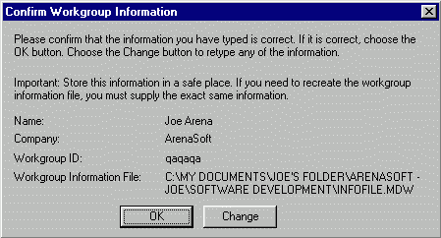Administative User:
User Name: Joe
Personal ID: wswsws
Password: ededed

Ordinary User:
User Name: admin
Password: pass

================================================

User-Level Security:
1) Give a user Read Data and Read Design permissions only. He can still import table into an unsecured database and access the data.
2) Remove all permissions from a Table. User can not open the table, open a form based on the table, or import the Table into another database. Get’s message “No permission to Import, Export, or Link to this Table”.

Securing RS Means Tables so that they can not be copied (imported) into another Access database:
1) Create user-level Security per book. Set user’s group permissions such that “users” have no permissions on Tables. Now they can not open a form that uses the tables, nor can they import the Table into another database. Make a Query for each Table (I used Tq before the Table name for Query name) and set the “RunPermissions” Property = Owner’s and give the users group full permissions on the query. To do this, I must change all forms, SUBS, & FUNCTIONS that use DAO statements and SQL statements to use the query that used to use the Table.
2) setting the “RunPermissions” Property = Owner’s is not always enough. Not sure why. Thus I changed every SQL statement, every recordset, etc to use the new Tq table query. This works.
3) Permissions set for objects for the “Users” group are:
Database Open/run, Open Exclusive
Tables No permissions
Query all permissions (administer permission was required because some functions create new queries such as “ExportZonesToExcel” function which the excel screen uses to create a pivot table. - see NOTE “A” below)
Forms Open/run
Reports Open/run
Macros Open/run
Modules no permissions
NOTE “A” - since new tables get full permissions for “users” by default, you must manually remove those permissions after creating a new table.
3) This procedure also works if splitting the database.
4) Sample SQL statement: SELECT RsmMainData.RsmMainID, RsmMainData.RsmMainLineNo, RsmMainData.RsmMainDescription, RsmMainData.RsmMainCrewKey, RsmMainData.RsmMainOutput, RsmMainData.RsmMainUnit, RsmMainData.RsmMainMat, RsmMainData.RsmMainLab, RsmMainData.RsmMainTot, RsmMainData.RsmMainTotOP, RsmMainData.RsmMainEquip, RsmMainData.RsmMainManHours, RsmMainData.RsmMainMonoTradeQty, RsmMainData.RsmMainWCPTfactor, RsmMainData.RsmMainOHPfactor
FROM RsmMainData WITH OWNERACCESS OPTION;
The “With Owner Access Option” does not always work. Add Tq prefix before all Table names in above does work.

Splitting the database:
1) Must provide easy was to relink tables when moved
2) Must change every place a Table type recordset was used (Seek method) to a Dynaset recordset

